# ETL Process considerations

## Directories and files

For the ETL process to work correctly, the following files and directories must be present, this is after having installed all the prerequisites. In the directory where the project will be created (etl_pyspark), the following directories must exist

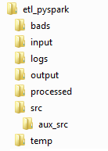

### Input directory

In the input directory is the uber_data.json file that will be uploaded to the tables in the SQL server. The file used for this project is based on the file uber_data.csv in the <https://github.com/darshilparmar/uber-etl-pipeline-data-engineering-project/tree/main/data> project.

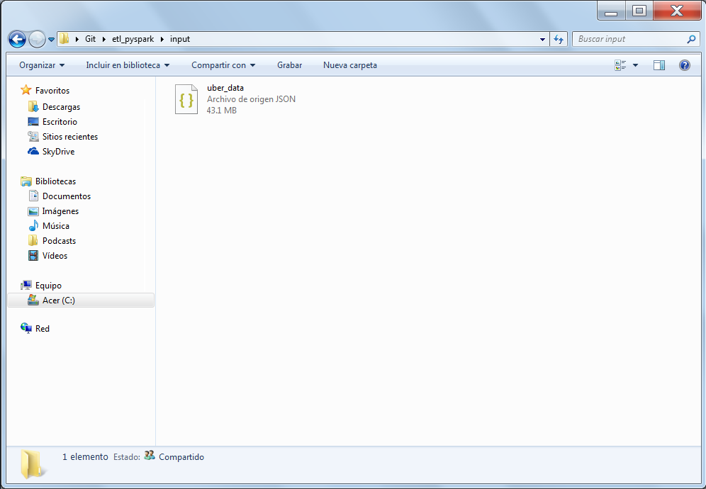

### Output directory

The output directory is used to save all the files that are generated in each of the extract, transform and load processes. When the extraction process is run, the uber_data_yyyymmdd.csv file is generated with the same records as the uber_data.json file.

Remember that the date in the name of the files created is the day the process was executed.

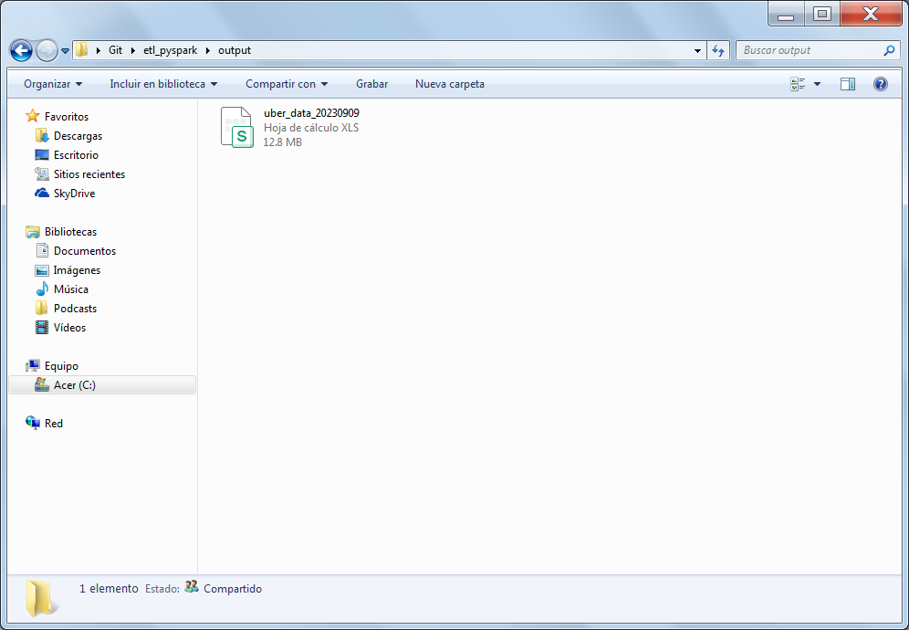

In the following link you can see the output log of the Extract process that creates the csv file described.



This file is the basis for creating the files in the following transform and load stages. With the exception of files that load to the following tables

CAT_TARIFA

CAT_TIPO_PAGO

This is because these catalogs are created based on a file found in the following link

<https://www.nyc.gov/assets/tlc/downloads/pdf/data_dictionary_trip_records_yellow.pdf>

In the case of the following table, there was no value associated with its description, so the values were invented.

CAT_PROVEEDOR

### Temp directory

The temporary directory is used to create the csv files. This is because in pyspark, when creating a file, only the path where you want to create the file is passed, the process creates four files of which one of them is the file with the information in csv format, as you can see next.

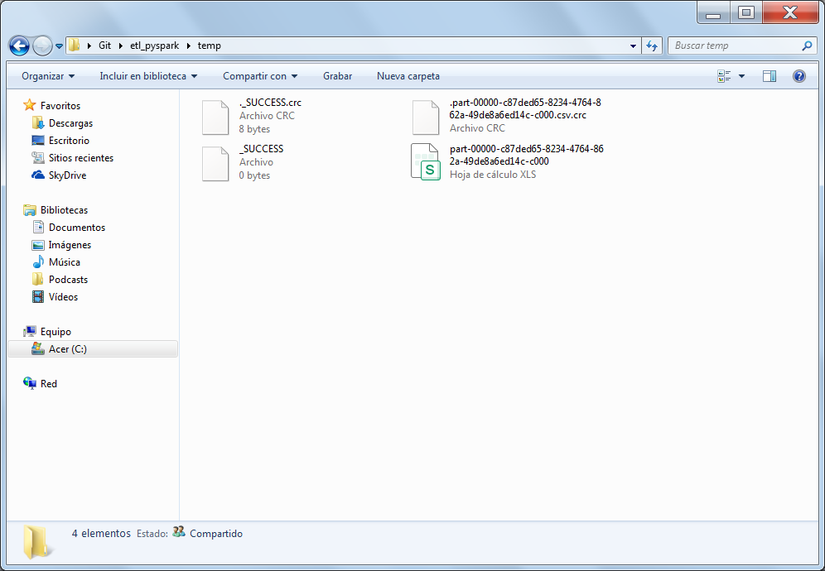

When one of the processes creates a file, the next steps are to change the name and directory of the file with the csv format to the output directory. When one of the processes creates a file, the next step is to change the name and directory of the file with the csv format to the output directory.

When the file has already been renamed and moved to the output directory, the files that are in the temporary directory are deleted, since it must always be empty for the following files that will be created.

This can be seen in the output log of the transform process, since the process generates several files.



This can be seen in the output log of the transform process, since the process generates several files.

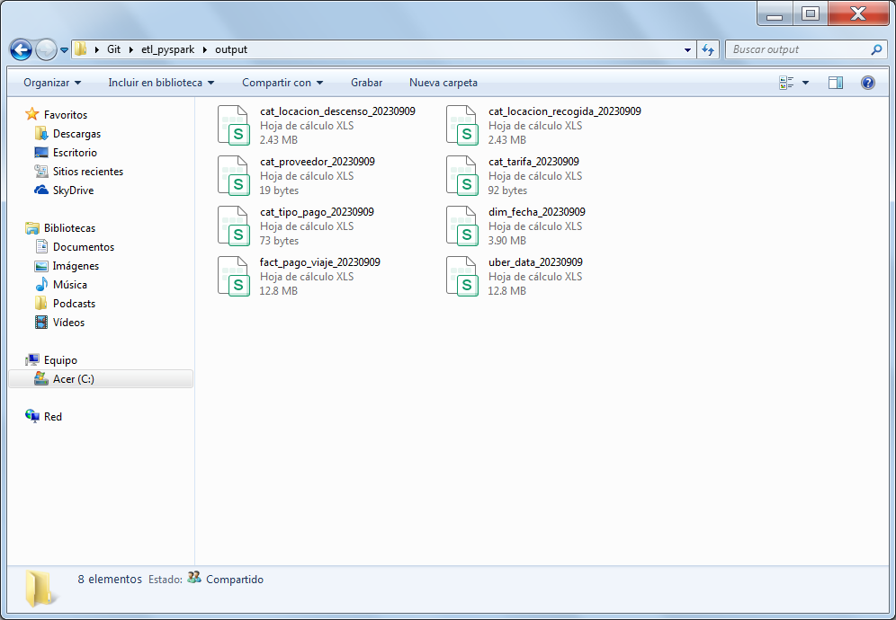

### Logs directory

The logs directory is used to create the log files. Either the files that each process generates automatically or the files with the console output logs.

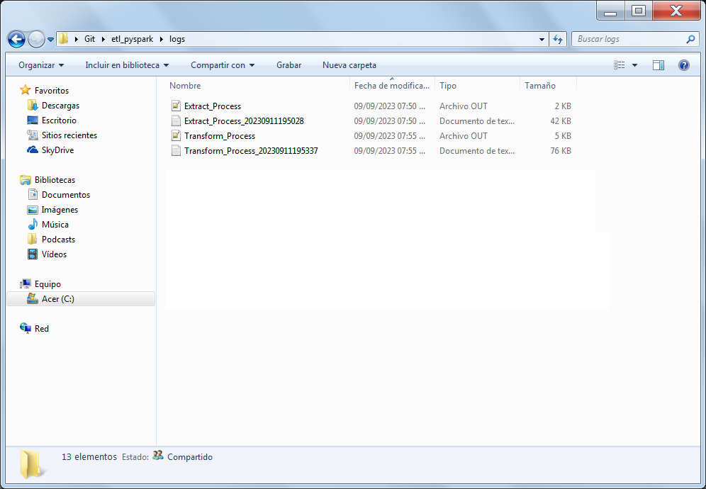

### Bads directory

The bads directory is used to create a bad file. This file is used to validate that the load to the FACT_PAGO_VIAJE table doesn’t have the IDs that were generated in the other tables with a null value. If everything is correct, the file should be generated without data.

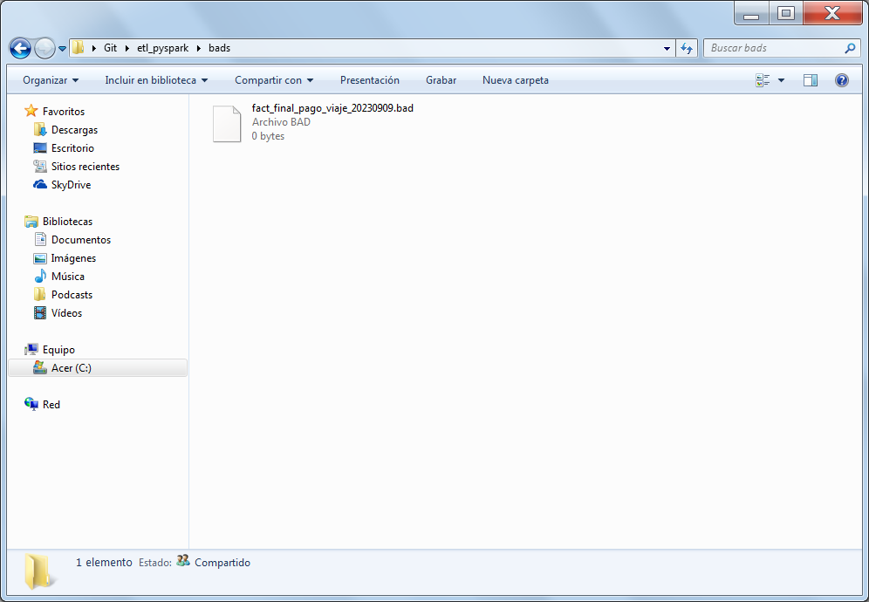

### Processed directory

The processed directory is used to copy the uber_data.json and uber_data_yyyymmdd.csv files. When the tables have already been loaded.

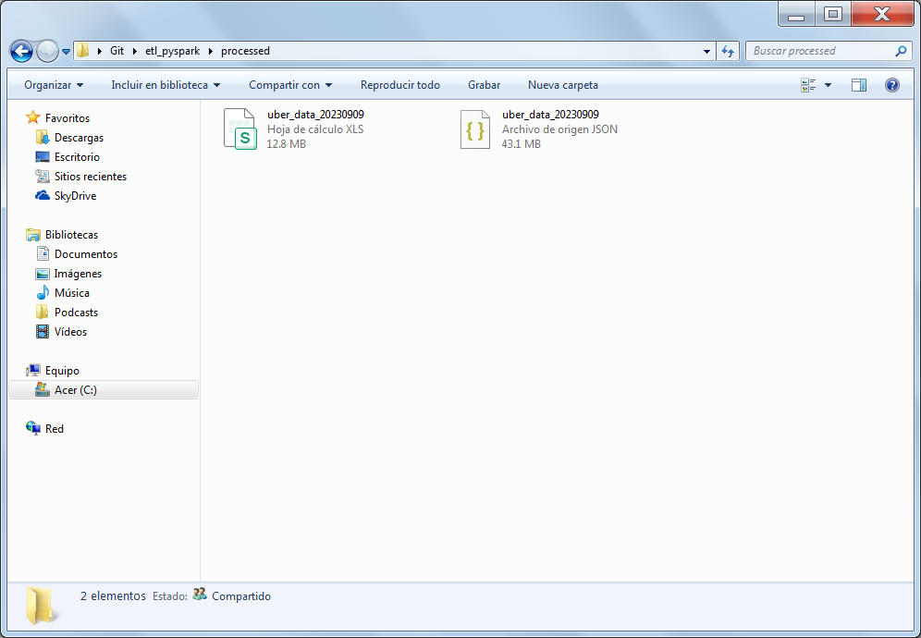

### Src directory

The src directory contains the Python files that run the Extract, Transform, and Load processes. Also, a file with some runtime errors. Also, a file with some runtime errors.

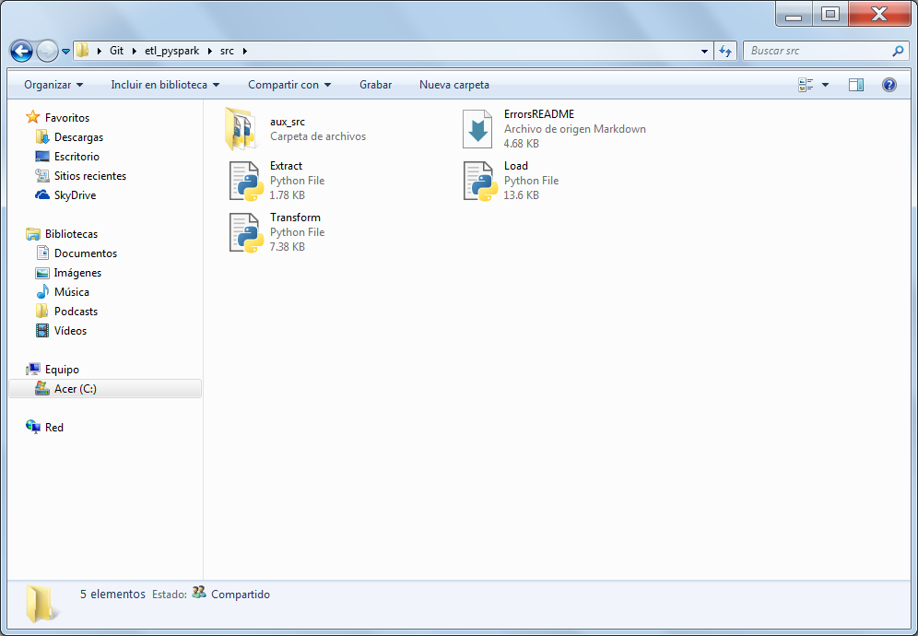

### Aux_src directory

The aux_src directory contains the Python files that help with the execution of the Extract, Transform and Load processes.

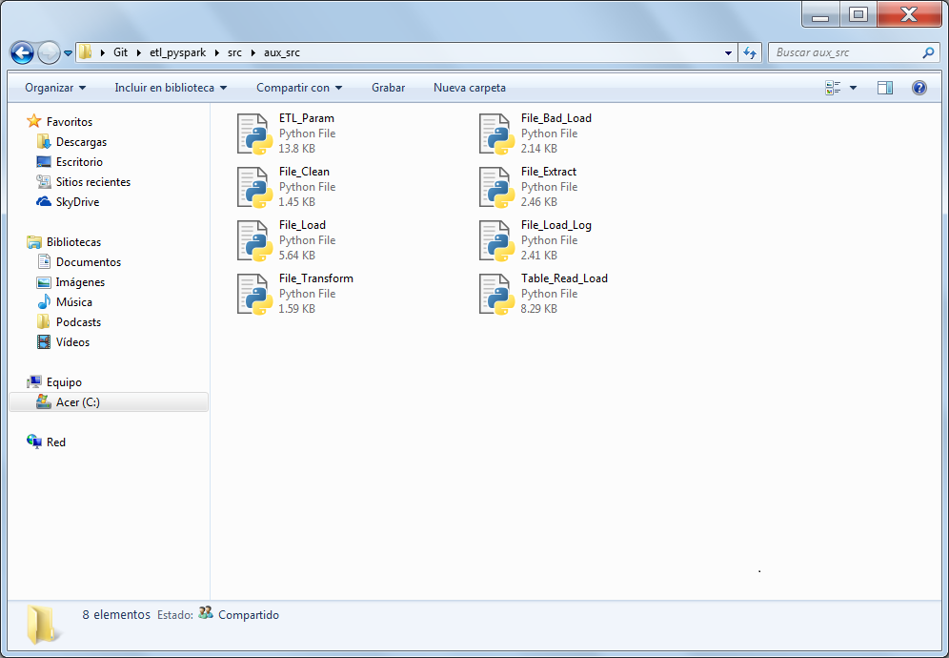

### Extract.py

The Extract.py file executes the process that creates the uber_data_yyyymmdd.csv file in the output path. This file is the basis for generating the other files for loading into the tables.

To achieve this, run the next functions from the File_Extract.py file

deleteFile()

createFile()

Finally, gets the next parameter from the ETL_Param.py file.



### File_Extract.py

The File_Extract.py file helps to create the csv file from the uber_data.json file. This file gets the next parameters from the ETL_Param.py file



Creates the csv file in the tmp directory, renames it and moves it to the output directory and deletes the files that are generated in addition to the csv file in the temp directory.

### Transform.py

The Transform.py file executes the process that creates the next files in the output path



To achieve this, run the next functions from the File_Transform.py file

deleteFile()

createFile()

Finally, gets the next parameters from the ETL_Param.py file.



### File_Transform.py

The File_Transform.py file helps to create the csv files from the uber_data_yyyymmd d.csv file. This file gets the next parameters from the ETL_Param.py file



Creates the csv files in the tmp directory, renames them and moves them to the output directory and deletes the files that are generated in addition to the csv file in the temp directory.

### Load.py

The Load.py file runs the process that loads the following files into the tables in SQL Server and prepares the directories for new execution



To achieve this, run the next functions from the File_Load.py file

loadTable()

readTables()

deleteFile()

To achieve this, run the next function from the File_Load_Bad.py file

createBadFile()

To achieve this, run the next function from the File_Load_Log.py file

loadLogTable()

To achieve this, run the next function from the File_Clean.py file

cleanPaths()

Finally, gets the next parameters from the ETL_Param.py file and defined queries from the Table_Load_Read.py file



### File_Load.py

The File_Load.py file helps to load the csv files into the SQL server tables and creates the csv files that validate the information in the image tables with the final tables, for later loading into the final tables. This file gets the next parameters from the ETL_Param.py file and .env file



When a table is loaded, the file generates a log csv file with a record that will be used to load the log table.

Creates the csv files in the tmp directory, renames them and moves them to the output directory and deletes the files that are generated in addition to the csv file in the temp directory.

### File_Load_Bad.py

The file File_Load_Bad.py generates a file that validates that the IDs of the catalogs and the dimensional table do not have null values, this file is created in the temporary directory and then renamed and moved to the bads directory. This file gets the next parameters from the ETL_Param.py file



### File_Load_Log.py

The File_Load_Log.py file loads the log csv file generated in the File_Load.py file into the log table. This file gets the next parameters from the ETL_Param.py file and .env file



### File_Clean.py

The File_Clean.py file is the last file to be executed, copies the uber_data.json and uber_data_yyyymmdd.csv files to the processed directory and cleans the bads, temp and output directories.

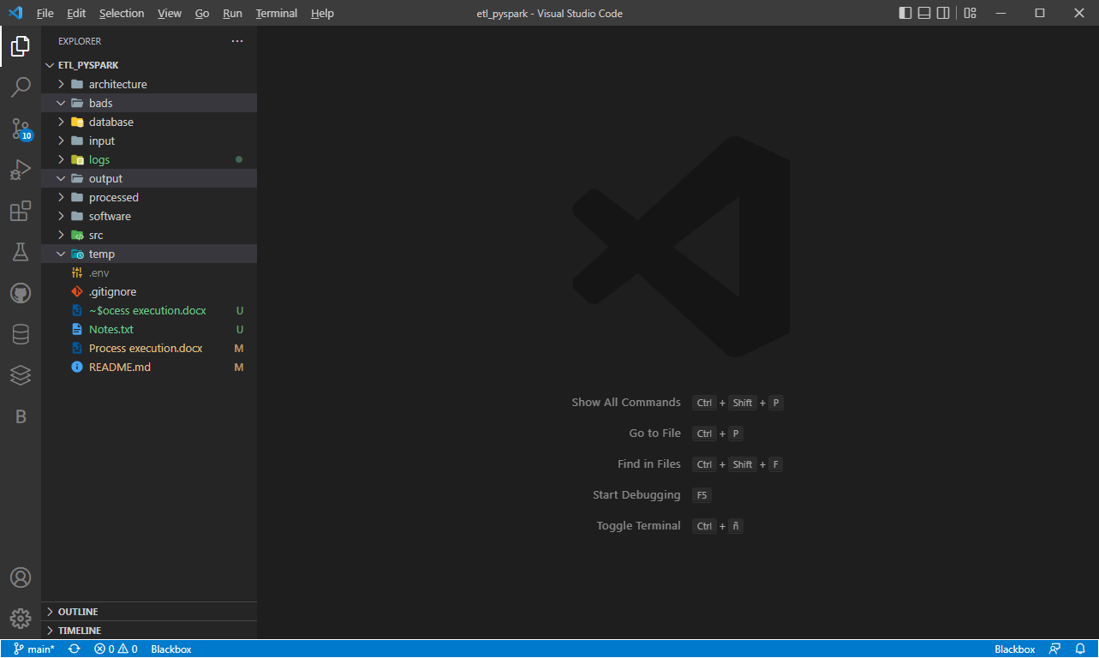

### Database

When the process is complete, you can review the information in the database model views. The VDIM_LOG_CARGA view contains the records loaded into all tables

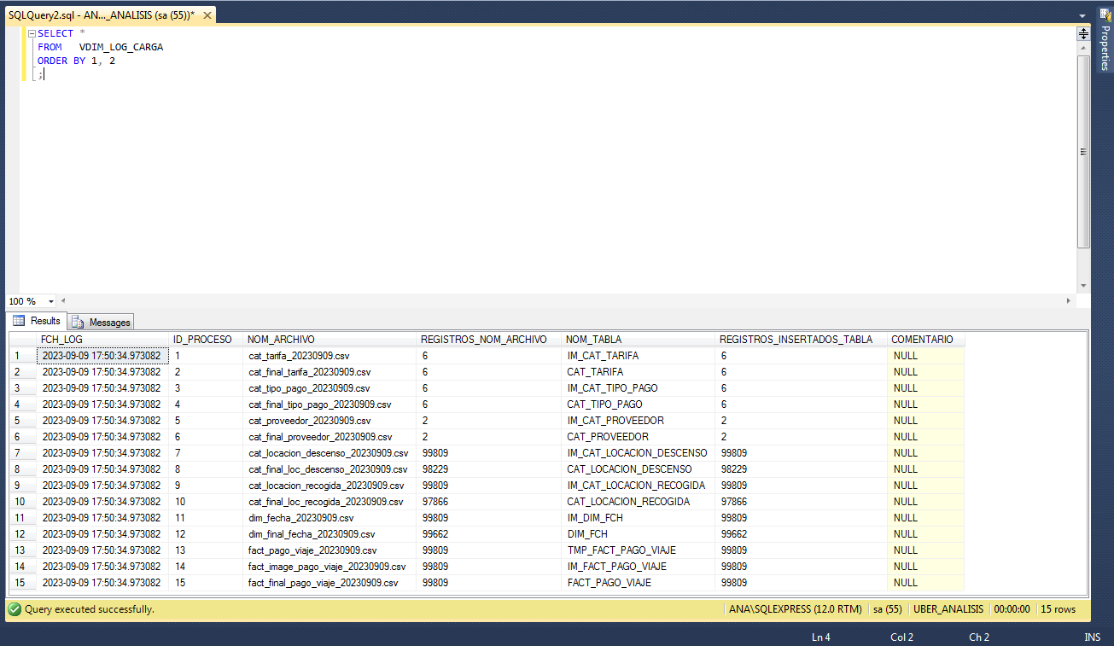

If we count each view, we can see that the numbers returned by the counts are the same as those in the VDIM_LOG_LOAD view.

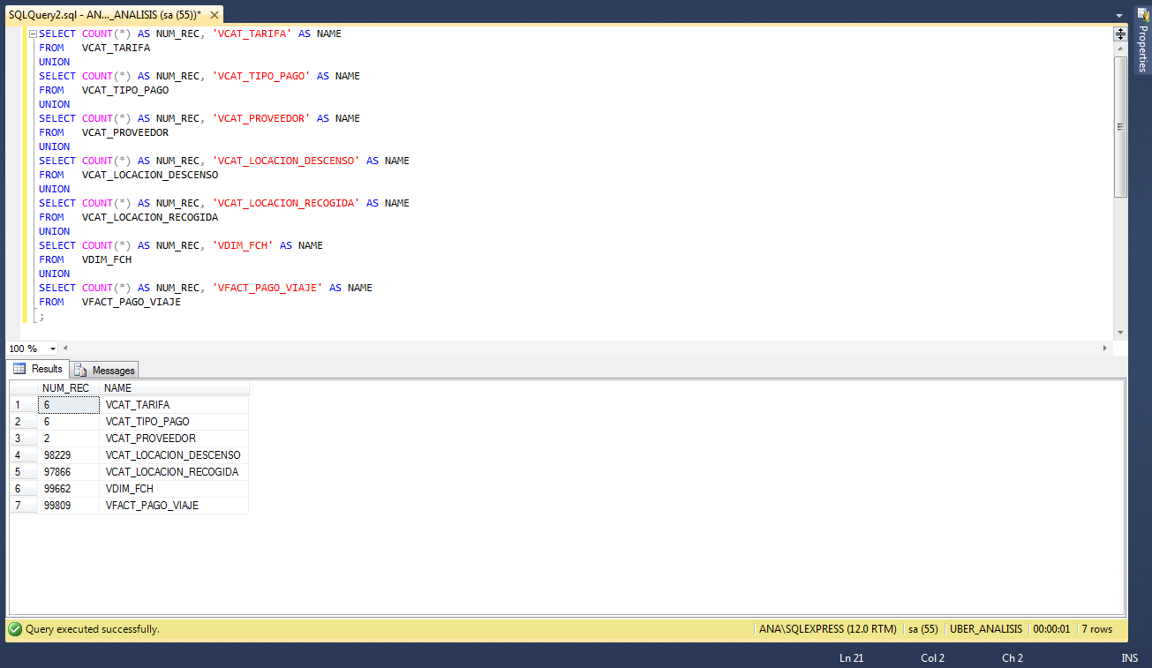

When validating the records in the json file, you can see that they are the same ones (99809 records) that were loaded in the FACT_TYPE_VOYAGE table, so there is no loss of information in the ETL process.

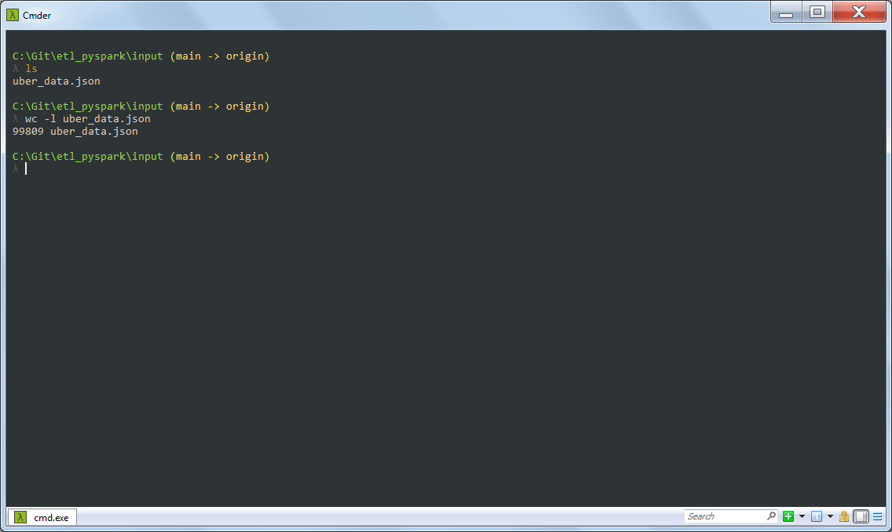

This process was done as if they sent loading information every day. Therefore, validations were made so that the tables did not have duplicate values, only the new ones were uploaded.

This is why if the process were executed several times even on the same day, the information loaded into the tables will not have inconsistencies in the data.

Next, you can see how when you run the process again and how the source of the information is still the same file, the information was not loaded again, saving processing time, and in the log table you can see how the records loaded to the final tables were zero.

